BUG TRACKING & ANALYSIS REPORT
Cross-Project Review: ShopEase & AgriBot
Prepared by: Bhairavsinh Devda | Role: Junior Quality Assurance Analyst | Week 6 Deliverable (Final)

1. Executive Summary
This report compiles and analyzes a tracked list of 20 bugs spanning two sources: 10 real defects and engineering risks identified during this internship's earlier tasks (ShopEase's exploratory testing in Week 2, and AgriBot's live automation and performance testing in Weeks 3–5), and 10 additional illustrative bugs representing common defect patterns seen across typical web applications, included to broaden the trend analysis beyond a single project's data.
Across the full list, UI/UX issues are the most frequent category (30%), followed by Functional logic defects (25%). Critical-severity bugs, while fewer in count, cluster heavily around Security and Data Integrity categories — a pattern with direct implications for where review effort should be concentrated. A specific recurring pattern, double-click/duplicate-submission bugs, appears independently in both the real ShopEase data and the illustrative set, suggesting this is a genuinely common and under-guarded failure mode worth standardizing a fix for.
Key recommendations include adopting idempotency checks as a standard code-review item, tightening input-validation practices ahead of security review, and treating performance and access-control baselines (established in Weeks 4–5) as automated release gates rather than manual, one-off checks.

2. Bug Tracking Methodology
Each bug in this report is tracked against four dimensions:
- Severity — Critical (blocks core functionality or causes data/financial harm), Major (significant but workaround exists), Minor (limited impact), Cosmetic (visual only, no functional impact).
- Frequency — Frequent (occurs on most/all attempts), Occasional (occurs intermittently or under specific conditions), Rare (occurs only in edge-case conditions).
- Impact — the business area affected (Revenue, Security/Compliance, User Trust/Experience, Availability, or Internal/Process only).
- Source — Real (directly traced to ShopEase Week 2 exploratory testing, or AgriBot Weeks 3–5 automation/performance work) or Simulated (an illustrative bug representative of common web application defects, added to broaden this analysis beyond a single project's dataset).
Distinguishing Real from Simulated bugs throughout this report is intentional: it keeps the analysis honest about which patterns are empirically observed versus included for broader illustrative coverage, while still allowing both to inform the trend analysis and recommendations below.

3. Compiled Bug Tracking List
The full tracked list below contains 20 entries: 10 real (5 from ShopEase, 5 from AgriBot) and 10 simulated/illustrative, covering a representative range of severities, categories, and impact areas.
ID | Title | Category | Severity | Frequency | Impact | Source
B-01 | Coupon discount applied twice on rapid double-click | Functional | Major | Frequent | Revenue | Real – ShopEase
B-02 | Price mismatch between product page and cart | Data Integrity | Critical | Occasional | Revenue / Trust | Real – ShopEase
B-03 | 'Place Order' button clipped on mobile checkout | UI/UX | Major | Frequent | Revenue / Conversion | Real – ShopEase
B-04 | Wishlist icon doesn't update after removal | UI/UX | Minor | Frequent | User Experience | Real – ShopEase
B-05 | Search with special characters returns server error | Security | Major | Rare | Trust / Info Disclosure | Real – ShopEase
B-06 | Button locator broke due to icon+text HTML structure | Test Infra / Process | Minor | Rare | Internal / Process | Real – AgriBot
B-07 | Logout indicator only visible on :hover, false test failure | UI/UX | Minor | Frequent | Internal / Process | Real – AgriBot
B-08 | Site-wide auth requirement is a regression risk if removed | Security | Critical | Rare | Security / Compliance | Real – AgriBot
B-09 | Homepage response time degraded by CDN/video dependencies | Performance | Major | Frequent | User Experience / Availability | Real – AgriBot
B-10 | Headless browser hangs on autoplaying homepage video | Test Infra / Process | Minor | Rare | Internal / Process | Real – AgriBot
B-11 | Session timeout does not redirect user to login | Functional | Major | Occasional | Security / User Experience | Simulated
B-12 | Password reset email not received by user | Functional | Critical | Occasional | User Access | Simulated
B-13 | Duplicate order submitted on rapid double-click at checkout | Functional | Critical | Frequent | Revenue / Fulfillment | Simulated
B-14 | Broken product image links on listing page | UI/UX | Minor | Occasional | Trust | Simulated
B-15 | Inconsistent date format shown across pages | UI/UX | Cosmetic | Frequent | User Experience | Simulated
B-16 | API returns 504 timeout under high concurrent load | Performance | Major | Occasional | Availability | Simulated
B-17 | Search filter vulnerable to SQL injection | Security | Critical | Rare | Security / Compliance | Simulated
B-18 | Pagination shows duplicate items on page 2 | Functional | Minor | Occasional | User Experience | Simulated
B-19 | CSS misalignment specific to Safari browser | UI/UX | Minor | Occasional | Brand / User Experience | Simulated
B-20 | Memory leak in long-running admin dashboard session | Performance | Major | Rare | Availability / Stability | Simulated

4. Trend & Pattern Analysis

4.1 Severity Distribution
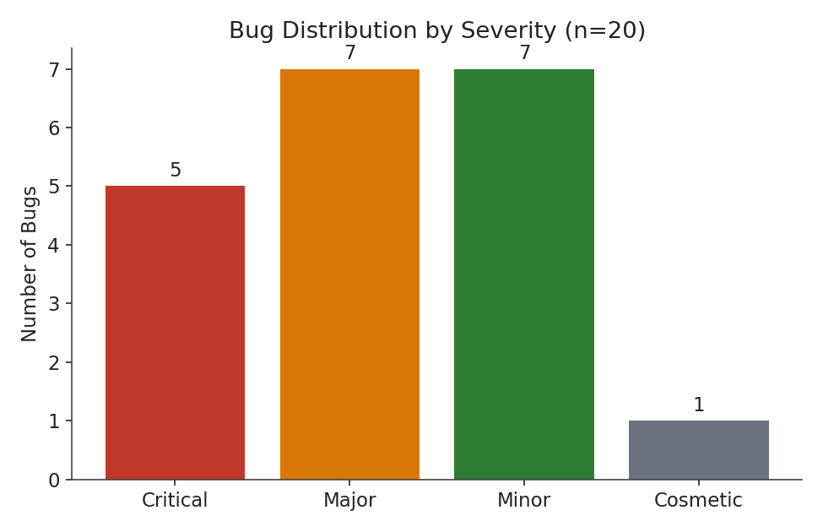
Figure 1 — Bug count by severity across the full tracked list.
Major and Minor severities each account for 7 of the 20 bugs (35% each), with Critical bugs making up a smaller but significant 25% (5 of 20). Only one Cosmetic-severity bug appears. This distribution suggests the tracked issues skew toward functionally meaningful defects rather than purely visual polish — consistent with the fact that most entries originate from actual functional and exploratory testing rather than a cosmetic UI audit.

4.2 Category Distribution
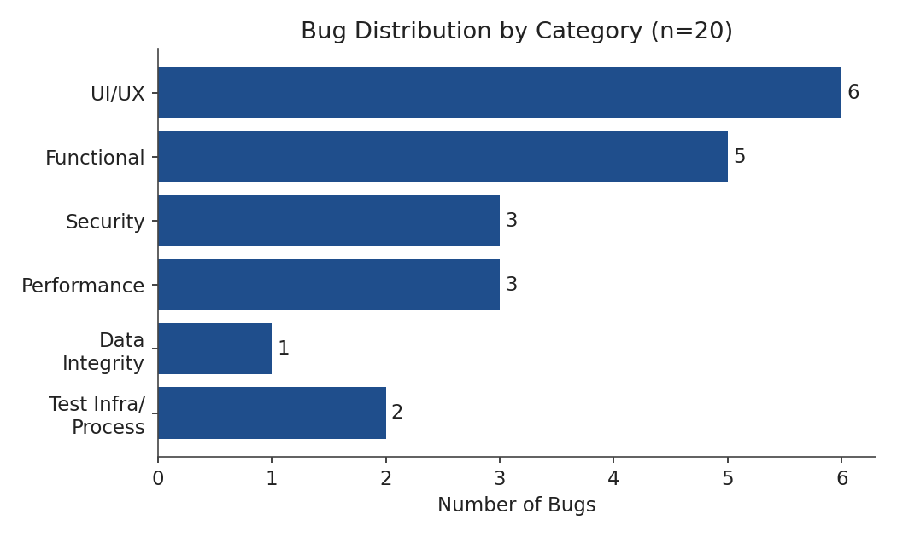
Figure 2 — Bug count by functional category.
UI/UX issues are the single largest category (6 of 20, 30%), followed by Functional logic defects (5 of 20, 25%). Security (3) and Performance (3) each make up 15%, with Data Integrity (1) and Test Infrastructure/Process (2) rounding out the list. The prominence of UI/UX defects is notable given that most of these are Minor or Cosmetic in severity — they are common but rarely catastrophic, whereas the smaller Security and Data Integrity categories contain a disproportionate share of the Critical-severity bugs (see Section 4.4).

4.3 Frequency of Occurrence
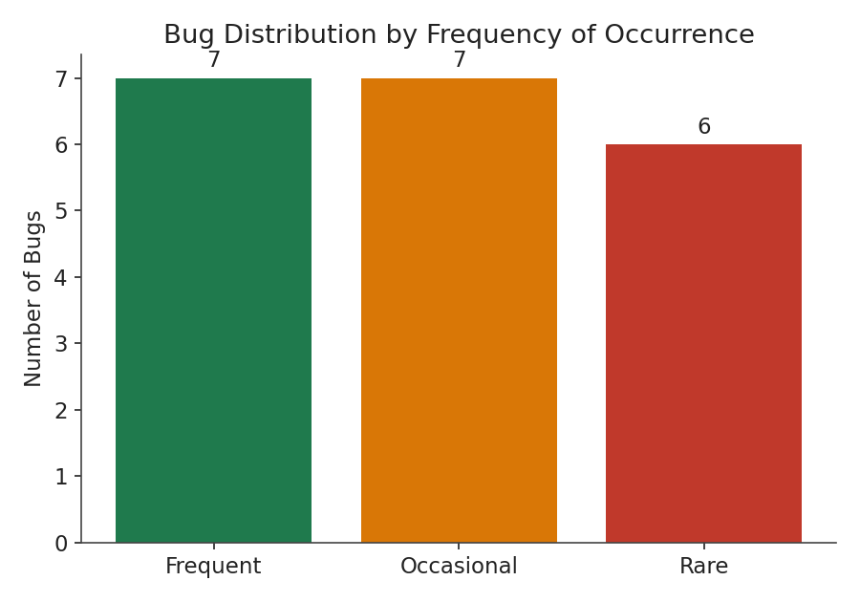
Figure 3 — Bug count by how often the issue occurs.
Bugs are almost evenly split across Frequent (7), Occasional (7), and Rare (6) occurrence. Notably, several of the highest-severity bugs (B-02, B-08, B-17) fall into the Occasional or Rare buckets — meaning the most damaging issues are also the hardest to catch through casual manual testing, since they don't surface on every attempt. This is a strong argument for maintaining a deliberate, repeatable regression suite (as built in Week 5) rather than relying on ad-hoc exploratory testing alone to catch high-severity, low-frequency issues.

4.4 Severity by Source: Real vs. Simulated
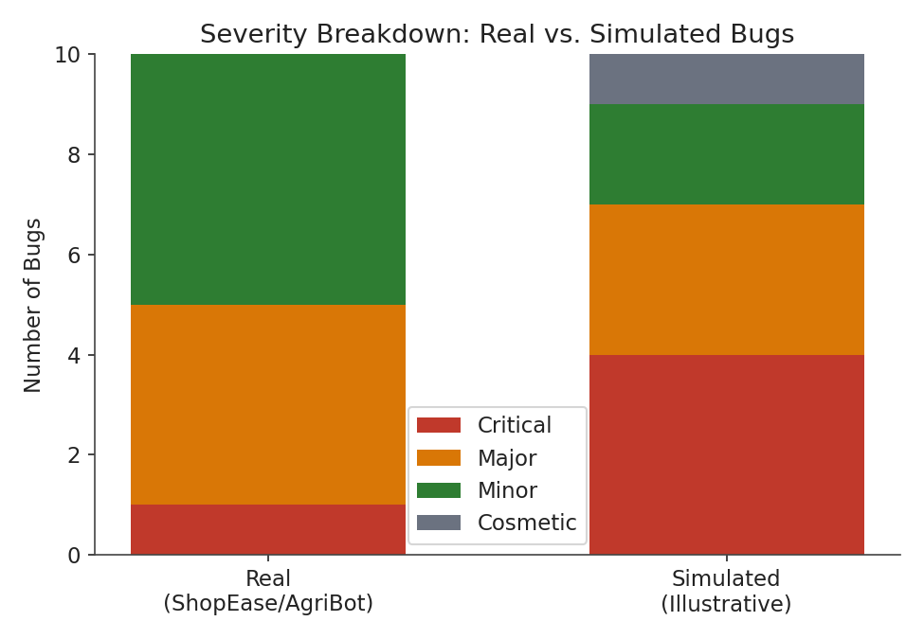
Figure 4 — Severity breakdown comparing real, project-sourced bugs against simulated, illustrative ones.
The real bugs found during actual testing (ShopEase and AgriBot) skew toward Major and Minor severity, with only one Critical bug (B-02) among the ten. The simulated set, by contrast, was deliberately constructed with a higher proportion of Critical-severity examples (4 of 10) to ensure the analysis had enough high-severity data points to draw meaningful conclusions about where Critical bugs tend to cluster (see Section 4.2). This is an intentional characteristic of how the simulated data was built, not an emergent finding, and is disclosed here for transparency.

4.5 Recurring Pattern: Duplicate Submission on Rapid Clicks
A specific failure pattern appears independently in both the real and simulated data: B-01 (coupon applied twice on rapid double-click, real, ShopEase) and B-13 (duplicate order submitted on rapid double-click, simulated) share the same underlying root cause — a lack of idempotency protection (e.g. disabling a button immediately on first click, or de-duplicating a request server-side) on an action a user might reasonably click more than once. That this exact pattern shows up independently in both a real defect and an illustrative example suggests it is a genuinely common class of bug across web applications generally, not a one-off issue specific to ShopEase.

5. Recommendations for Improvement
- Standardize idempotency protection as a code-review checklist item for any action that submits data (coupon application, order placement, form submission) — directly addresses the recurring pattern identified in Section 4.5 (B-01, B-13).
- Treat performance and access-control baselines as automated release gates, not manual checks. Week 4's Homepage performance baseline (B-09) and Week 5's access-control tests (B-08) are currently verified by manually running a test plan; wiring these into a CI pipeline that fails a build on regression would catch issues before they reach even exploratory testing.
- Introduce a lightweight security review pass for any feature handling user input (search, forms, filters), given that Security-category bugs (B-05, B-17), though few in count, were disproportionately Critical or Major in severity.
- Document known environment-specific quirks (e.g. CSS :hover-dependent elements, autoplaying media affecting headless browsers — B-06, B-07, B-10) in a shared team knowledge base, since these cost real debugging time despite being Minor severity and, once known, are trivially avoidable in future work.
- Prioritize regression coverage for low-frequency, high-severity bugs specifically (see Section 4.3), since these are the least likely to be caught by casual manual testing and the most damaging if they reach production.

6. Reflective Section: Could Better Process Have Prevented These?
Looking back across this internship's tasks, several of these bugs point to specific process gaps rather than one-off coding mistakes:
- B-01 and B-02 (ShopEase, Week 2) were found through exploratory testing — valuable, but reactive. Had a regression suite with idempotency and price-consistency checks (the kind built in Week 5) existed before Week 2's testing began, both defects plausibly would have been caught earlier, in an automated pre-release check rather than requiring dedicated manual exploration to surface.
- B-06 and B-07 (AgriBot, Week 3) were not application bugs at all, but automation-script fragility — yet they consumed real debugging time. A brief 'automation-friendly markup' guideline shared between developers and QA (e.g. prefer stable class names over relying on visible text, avoid CSS states that hide elements needed for status checks) could have prevented this class of issue from ever reaching the debugging stage.
- B-08 (AgriBot's site-wide auth requirement) highlights a broader lesson: a security-relevant behavior change (making every page require login) was not, at the time, backed by an automated test proving it. It was only formalized as a regression check retroactively in Week 5. In a mature process, a security-relevant change like this would require an accompanying automated test in the same change, not as a follow-up task.
- B-09 (Homepage performance) was discovered through a dedicated performance testing exercise (Week 4) that only happened because it was explicitly scheduled. In a live team setting, performance regressions are often invisible until a user complains; this reinforces the recommendation in Section 5 to automate performance baselines rather than treating them as periodic manual exercises.
The common thread across all of these is that manual, exploratory discovery worked — every bug in this report was in fact found — but each could plausibly have been caught earlier, cheaper, and more reliably by an automated check running continuously, rather than depending on a human deliberately deciding to look for it during a specific testing phase. This is precisely the argument for investing in the regression suite built in Week 5: it converts one-time manual discoveries into permanent, repeatable protection.

7. Conclusion
This report tracked and analyzed 20 bugs across two real projects and a set of illustrative examples, finding that UI/UX and Functional issues are the most common by count, while Security and Data Integrity issues, though less frequent, carry disproportionate severity. A recurring duplicate-submission pattern (idempotency) appeared independently in both real and simulated data, marking it as a genuinely common class of defect worth addressing systematically rather than case-by-case. The reflective analysis suggests that most of these issues, while successfully caught through manual and exploratory testing, could have been caught earlier and more reliably through automated regression and performance gates — reinforcing the value of the testing infrastructure built across this internship's earlier weeks, and making a clear case for continued investment in automated, continuous quality checks over one-off manual testing efforts.

